A
Project Report On

STUDENT ASSOCIATION MANAGEMENT



Prepared By

Pavan Patil 51
Hrushikesh Rajankar 54
Gopal Paraskar 49
Karan Nakum 47

Under the Guidance of:-Ms. D.R. Anekar

Department of Information Technology Sinhgad academy Of Engineering Kondhwa Bk. Pune
2020-2021

Sinhgad Academy of Engineering Department of Information Technology


CERTIFICATE
This is to certify that “Student Association Management” embodies the original work done by Pavan Patil, Hrushikesh Rajankar, Gopal Paraskar, Karan Nakum during this project submission as a partial fulfilment of the requirement for the Mini Project in subject DBMS of B.E. Degree, Vth Semester, of Savitribai Phule Pune University during the academic year 2020- 2021

(Ms.D.R. Anekar) (Mr.Abhay Adapanwar)
Project Guide H.O.D

External Examiner

Sr. No. | Index | Page No.
1 | Introduction | 1
2 | Scope and Limitation | 2
3 | Requirement Analysis | 3
4 | Feasibility Study | 4
5 | System Requirement | 6
6 | Design (ER Diagram) | 7
7 | ER to Table Conversion | 8
8 | Normalization | 9
9 | Schema Diagram | 14
10 | Coding(DDL,DML,Connectivity) | 15
11 | Screenshots | 31
12 | Future Scope and Enhancement | 38
13 | Conclusion | 39
14 | Reference | 40

Introduction

The Auto-Spare Part Management is developed for sale/purchase organization. This system manages customer, product, sales order, and dealer and purchase order. It provides a platform to the trader to automate their record keeping. The purpose of this project is to develop an application program to reduce the manual work for managing inventory, product, customer, dealer and orders. This project is built to help admin in managing his organization. Admin can store customer details in the database. Next time when customer comes in then there is no need to enter his details again. It can selected from the list displaying all customer

Functions of Auto-Spare Part Management:
- Admin can store all customer and dealer record.
- This application keeps tracks of all the products being sold in the organization.
- This system provides facility of making sales and purchase order.
- All products, customer and dealer record is maintained as master data. User can selected these from display list while making sales order and purchase order.

Scope and Limitation

  - Scope:
The main reason to build this project is to provide the seller a in-look of the shop. This project wills the guide owner to the products available in the shop and which are required to order from the sellers. By this, shopkeeper doesn’t have to keep track of the records manually. The more comfortable users of computerized systems were mostly users with a fair accounting knowledge. In some cases business owners left the entire system to the accountant who was more familiar with the system, a situation some said possess a business risk. Deductions from the requirements analysis show that ease of use and knowledge prerequisite are the main reasons why most SMEs are not able to adopt computerized systems fully for tracking and managing their sales processes. This situation makes them stick to old and sometimes wasteful methods of tracking sales. The effect of this is loss of profits due to poor record keeping. Project managers use feasibility studies to discern the pros and cons of undertaking a project before they invest a lot of time and money into it.

Limitation:
    - The process of gathering information and the record is time consuming. Since the system, response time is high.
    - Only the person who manages it regularly can handle it in proper direction.
    - The system allows one participant to register for only one event. A single user can’t get registered for more than one event

Requirement Analysis

The Requirements analysis was done to ascertain the type of sales management systems used by the SMEs and users experiences with the existing systems. This process led to the identification of two major types of systems namely; manual systems and computerized systems.
In response to questions about which of the two types of systems was preferred most of the businesses using the manual systems where daily sales books are maintained chose the computerized systems as most effective and convenient but cited factors such as difficulty of use, cost of acquiring full package and technical functions as reasons for not using them. It was also noted that some of the users of computerized systems also kept daily sales books, explaining that their sales persons needed a more formal training to be able to use the system effectively and for that matter it was convenient to keep a daily sales book to help identify error entries and sales misrepresentations.
The more comfortable users of computerized systems were mostly users with a fair accounting knowledge. In some cases business owners left the entire system to the accountant who was more familiar with the system, a situation some said possess a business risk. Deductions from the requirements analysis show that ease of use and knowledge prerequisite are the main reasons why most SMEs are not able to adopt computerized systems fully for tracking and managing their sales processes. This situation makes them stick to old and sometimes wasteful methods of tracking sales. The effect of this is loss of profits due to poor record keeping. Hence we sought to build a sales management system with friendly and interactive user interfaces which is easy to learn and use. However, the design does not compromise the security or integrity of business processes, and is intended to streamline transactions to eliminate user level errors such as misrepresentation of sales, uncaptured transactions and error entries.

Feasibility Study

1. What Is a Feasibility Study?
- A feasibility study is an analysis that takes all of a project's relevant factors into account—including economic, technical, legal, and scheduling considerations—to ascertain the likelihood of completing the project successfully. Project managers use feasibility studies to discern the pros and cons of undertaking a project before they invest a lot of time and money into it.
- Feasibility studies also can provide a company's management with crucial information that could prevent the company from entering blindly
into risky businesses.
- Types of Feasibility Study:

Technical Feasibility:
This assessment focuses on the technical resources available to the organization. It helps organizations determine whether the technical resources meet capacity and whether the technical team is capable of converting the ideas into working systems. Technical feasibility also involves the evaluation of the hardware, software, and other technical requirements of the proposed system. As an exaggerated example, an organization wouldn’t want to try to put Star Trek’s transporters in their building—currently; this project is not technically feasible.

Economic Feasibility:
This assessment typically involves a cost/ benefits analysis of the project, helping organizations determine the viability, cost, and benefits associated with a project before financial resources are allocated. It also serves as an independent project assessment and enhances project credibility—helping decision-makers determine the positive economic benefits to the organization that the proposed project will provide.

Legal Feasibility:
This assessment investigates whether any aspect of the proposed project conflicts with legal requirements like zoning laws, data protection acts or social media laws. Let’s say an organization wants to construct a new office building in a specific location. A feasibility study might reveal the organization’s ideal location isn’t zoned for that type of business. That organization has just saved considerable

time and effort by learning that their project was not feasible right from the beginning.

Scheduling Feasibility:
This assessment is the most important for project success; after all, a project will fail if not completed on time. In scheduling feasibility, an organization estimates how much time the project will take to complete.

Operational Feasibility:
Operational feasibility studies also examine how a project plan satisfies the requirements identified in the requirements analysis phase of system development.

5. System Requirement

Hardware Requirement:
  - Core to Dual or above
  - 2 GB RAM
  - 25 GB Free Hard disk space
  - Network interface card or Modem
  - LAN Network

Software Requirements:
  - Windows XP/7/8/10
  - Linux
  - DBMS
  - NetBeans IDE 8.0.2
  - SQL databases

Design (ER Diagram)

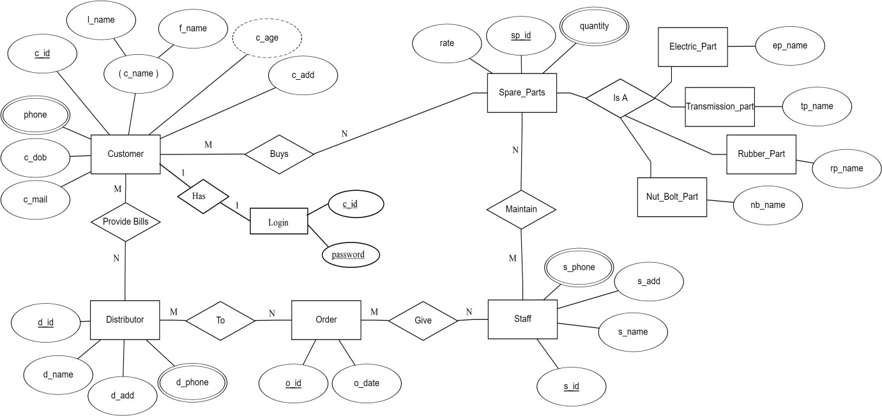

Fig.: ER Diagram of Auto-Spare Part Management

ER to Table Conversion

Customer Table

c_id | c_dob | phone | c_mail | l_name | f_name | c_add | c_age

  - Distributor

d_id | d_name | d_add | d_phone

  - Staff

s_id | s_name | s_add | s_phone

  - Spare_Parts

sp_id | rate | quantity

  - Order

o_id | o_date

- Normalization (up to 3NF)

- Customer Table

c_id | c_dob | phone | c_mail | l_name | f_name | c_add | c_age

C_id->f_name, l_name, c_dob, phone, c_mail, c_add, c_age; The Customer Table is in 1 NF as:
  - In above table attribute c_phone can contain multiple values.
  - So it can be further devided into two tables, with separate “Phone” table as below –
  - Phone Table

c_id | phone

c_id ->phone;

  - Customer Table

c_id | c_dob | c_mail | l_name | f_name | c_add | c_age

C_id->f_name, l_name, c_dob, c_mail, c_add, c_age;

The Customer Table is in 2 NF as:
    - Customer Table is in 1 NF
    - Candidate key : c_id, c_mail
    - Non prime attributes : c_dob, f_name, l_name, c_add, c_age
    - No partial dependency here (no change)

The Customer Table is in 3 NF as:
  - It is in 2 NF
  - c_id,c_mail - >c_name (candidate key)

c_id,c_mail - >c_add (candidate key) c_id,c_mail - >c_dob (candidate key) c_dob - >c_age (Transitive Dependency)
  - Here c_age is transitively dependent on candidate key c_id,c_mail.
    - 1.3 Customer_age Table

c_dob | c_age

C_dob-> c_add ;

- Distributor

d_id | d_name | d_add | d_phone

d_id->d_name, d_phone, d_add; The Distributor Table in 1 NF as:
  - In above table attribute c_phone can contain multiple values.
  - So it can be further devided into two tables, with separate “Phone” table as below –
  - Phone Table

d_id | phone

d_id ->phone;

  - Distributor Table

d_id | d_name | d_add

d_id->d_name, d_add ;

The Distributor Table is in 2 NF as:
  - It is in 1 NF
  - Here , d_id- >d_name (primary key)
d -> d_add (primary key) d-> phone (primary key)
    - No partial dependency here (no change)

The Distributor Table is in 3 NF as:
  - It is in 2 NF
  - NO transitive dependency here in Distributor table.

- Staff

s_id | s_name | s_add | s_phone

s_id->s_name, s_phone, s_add; The Staff Table in 1 NF as:
  - In above table attribute s_phone can contain multiple values.
  - So it can be further devided into two tables, with separate “Phone” table as below –
  - Phone Table

s_id | phone

s_id ->phone;

  - Staff Table

s_id | s_name | s_add

s_id->s_name, s_add;

The Staff Table is in 2 NF as:
  - It is in 1 NF
  - Here , s_id- >s_name (primary key)
s -> s_add (primary key) s-> phone (primary key)
    - No partial dependency here (no change)

The Staff Table in 3 NF as:
  - It is in 2 NF
  - NO transitive dependency Here in staff table.

- Spare_Parts

sp_id | rate | quantity

Sp_id->rate, quantity;
The Spare_parts Table is in 1 NF as:
  - All the underlying domains of the relation contain atomic (indivisible) values.
  - No repeating groups in the table.
  - All attributes dependent on primary key.
  - No change here

The Spare_parts Table is in 2 NF as:
  - It is in 1 NF
  - Functiona dependencies here – Sp_id ->rate (primary key) Sp_id ->quantity (primary key)
    - No Partial Dependency Here.

The Spare_parts Table is in 3 NF as:
  - It is in 2 NF
  - It includes no transitive dependencies as there are no non key attributes.
  - No change.

- Order

o_id | o_date

O_id-> o_date;
The Order Table is in 1 NF as:
  - All the underlying domains of the relation contain atomic (indivisible) values.
  - No repeating groups in the table.
  - All attributes dependent on primary key.

The Order Table is in 2 NF as:
  - It is in 1 NF
  - It includes no partial dependencies as every non key attribute is fully dependent on the primary key.
The Order Table is in 3 NF as:
  - It is in 2 NF
  - No transitive Dependency (no change).

Schema Diagram

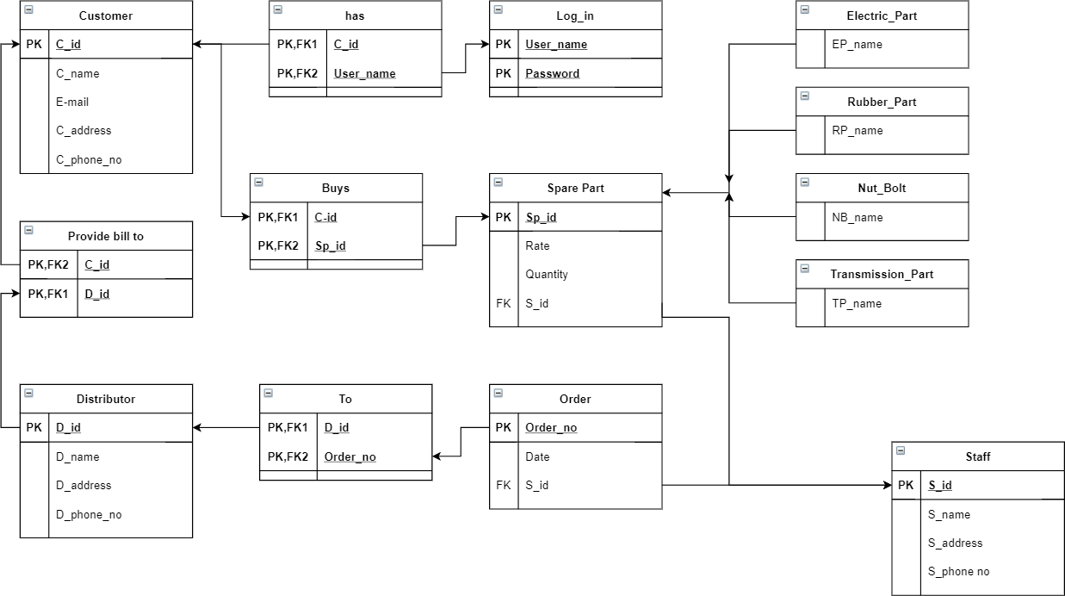

Fig.: Schema diagram for Auto-Spare Management

Coding (DDL,DML,Connectivity)

DDL and DML commands
-- phpMyAdmin SQL Dump
-- version 5.0.2
-- https://www.phpmyadmin.net/
--
-- Host: 127.0.0.1
-- Generation Time: Nov 11, 2020 at 06:43 AM
-- Server version: 10.4.14-MariaDB
-- PHP Version: 7.4.9

SET SQL_MODE = "NO_AUTO_VALUE_ON_ZERO"; START TRANSACTION;
SET time_zone = "+00:00";

/*!40101 SET @OLD_CHARACTER_SET_CLIENT=@@CHARACTER_SET_CLIENT */;
/*!40101 SET @OLD_CHARACTER_SET_RESULTS=@@CHARACTER_SET_RESULTS */;
/*!40101 SET @OLD_COLLATION_CONNECTION=@@COLLATION_CONNECTION */;
/*!40101 SET NAMES utf8mb4 */;

--
-- Database: `spare_parts`
--

-

--
-- Table structure for table `category`
--

CREATE TABLE `category` (
`CATEGORY_ID` int(11) NOT NULL,

`CNAME` varchar(50) DEFAULT NULL
) ENGINE=InnoDB DEFAULT CHARSET=latin1;

--
-- Dumping data for table `category`
--

INSERT INTO `category` (`CATEGORY_ID`, `CNAME`) VALUES (1, 'Electric_parts'),
(2, 'Metal_parts'),
(3, 'Rubber_parts'),
(4, 'Tranmission_parts');

--
-- Table structure for table `customer`

--

CREATE TABLE `customer` (
`CUST_ID` int(11) NOT NULL,
`FIRST_NAME` varchar(50) DEFAULT NULL,
`LAST_NAME` varchar(50) DEFAULT NULL,
`PHONE_NUMBER` varchar(11) DEFAULT NULL
) ENGINE=InnoDB DEFAULT CHARSET=latin1;

--
-- Dumping data for table `customer`
--

INSERT INTO `customer` (`CUST_ID`, `FIRST_NAME`,
`LAST_NAME`, `PHONE_NUMBER`) VALUES (17, 'kunal', 'kamra', '9873635464'),
(18, 'gaurav', 'patil', '8934827482'),
(19, 'arnab', 'goswami', '9876478974'),
(20, 'amit', 'shah', '8678947353'),
(21, 'narendra', 'modi', '7865346734');

--
-- Table structure for table `employee`
--

CREATE TABLE `employee` (
`EMPLOYEE_ID` int(11) NOT NULL,
`FIRST_NAME` varchar(50) DEFAULT NULL,
`LAST_NAME` varchar(50) DEFAULT NULL,
`GENDER` varchar(50) DEFAULT NULL,
`EMAIL` varchar(100) DEFAULT NULL,
`PHONE_NUMBER` varchar(11) DEFAULT NULL,
`JOB_ID` int(11) DEFAULT NULL,
`LOCATION_ID` int(11) DEFAULT NULL,
`HIRED_DATE` varchar(50) DEFAULT NULL
) ENGINE=InnoDB DEFAULT CHARSET=latin1;

--
-- Dumping data for table `employee`
--

INSERT INTO `employee` (`EMPLOYEE_ID`, `FIRST_NAME`,
`LAST_NAME`, `GENDER`, `EMAIL`, `PHONE_NUMBER`, `JOB_ID`,
`LOCATION_ID`, `HIRED_DATE`) VALUES
(1, 'pavan', 'patil', 'Male', 'pavan@gmail.com', '9876567865', 1, 113, NULL),
(5, 'karan', 'nakum', 'Male', 'karan@gmail.com', '89763546334', 1, 163, NULL),
(6, 'hrushikesh', 'rajankar', 'Male', 'rushi@gmail.com', '9874657834', 2, 164, NULL),
(7, 'gopal', 'paraskar', 'Male', 'gopal@gmail.com', '7894653125', 2, 165, NULL);

--
-- Table structure for table `job`

--
CREATE TABLE `job` (
`JOB_ID` int(11) NOT NULL,
`JOB_TITLE` varchar(50) DEFAULT NULL
) ENGINE=InnoDB DEFAULT CHARSET=latin1;

--
-- Dumping data for table `job`
--

INSERT INTO `job` (`JOB_ID`, `JOB_TITLE`) VALUES
(1, 'Manager'),
(2, 'Cashier');

--
-- Table structure for table `location`
--

CREATE TABLE `location` (
`LOCATION_ID` int(11) NOT NULL,
`PROVINCE` varchar(100) DEFAULT NULL,
`CITY` varchar(100) DEFAULT NULL
) ENGINE=InnoDB DEFAULT CHARSET=latin1;

--
-- Dumping data for table `location`
--

INSERT INTO `location` (`LOCATION_ID`, `PROVINCE`, `CITY`) VALUES
(113, | 'pune', | 'kondhwa'),
(159, | 'pune', | 'kondhwa'),
(160, | 'pune', | 'kothrud'),
(161, | 'nagpur', 'kuhi'),
(162, | 'amravati', 'morshi'),
(163, | 'pune', 'katraj'),
(164, | 'nagpur', 'narkhed'),

(165, 'amravati', 'dhamangaon');

--
-- Table structure for table `manager`
--

CREATE TABLE `manager` (
`FIRST_NAME` varchar(50) DEFAULT NULL,
`LAST_NAME` varchar(50) DEFAULT NULL,
`LOCATION_ID` int(11) NOT NULL,
`EMAIL` varchar(50) DEFAULT NULL,
`PHONE_NUMBER` varchar(11) DEFAULT NULL
) ENGINE=InnoDB DEFAULT CHARSET=latin1;

--
-- Table structure for table `product`
--

CREATE TABLE `product` (
`PRODUCT_ID` int(11) NOT NULL,
`PRODUCT_CODE` varchar(20) NOT NULL,
`NAME` varchar(50) DEFAULT NULL,
`DESCRIPTION` varchar(250) NOT NULL,
`QTY_STOCK` int(50) DEFAULT NULL,
`ON_HAND` int(250) NOT NULL,
`PRICE` int(50) DEFAULT NULL,
`CATEGORY_ID` int(11) DEFAULT NULL,
`SUPPLIER_ID` int(11) DEFAULT NULL,
`DATE_STOCK_IN` varchar(50) NOT NULL
) ENGINE=InnoDB DEFAULT CHARSET=latin1;

--
-- Dumping data for table `product`
--

INSERT INTO `product` (`PRODUCT_ID`, `PRODUCT_CODE`, `NAME`,
`DESCRIPTION`, `QTY_STOCK`, `ON_HAND`, `PRICE`,
`CATEGORY_ID`, `SUPPLIER_ID`, `DATE_STOCK_IN`) VALUES
(28, | '1', | 'wires', | '', | 1, | 1, | 300, |  | 4, | 19, | ''),
(29, | '1', | 'wires', | '', | 1, | 1, | 300, |  | 4, | 19, | ''),
(30, | '1', | 'wires', | '', | 1, | 1, | 300, |  | 4, | 19, | ''),
(31, | '1', | 'wires', | '', | 1, | 1, | 300, |  | 4, | 19, | ''),
(32, | '1', | 'wires', | '', | 1, | 1, | 300, |  | 4, | 19, | ''),
(33, | '1', | 'wires', | '', | 1, | 1, | 300, |  | 4, | 19, | ''),
(34, | '1', | 'wires', | '', | 1, | 1, | 300, |  | 4, | 19, | ''),
(35, | '1', | 'wires', | '', | 1, | 1, | 300, |  | 4, | 19, | ''),
(36, | '1', | 'wires', | '', | 1, | 1, | 300, |  | 4, | 19, | ''),
(37, | '1', | 'wires', | '', | 1, | 1, | 300, |  | 4, | 19, | ''),
(38, | '1', | 'wires', | '', | 1, | 1, | 300, |  | 4, | 19, | ''),
(39, | '1', | 'wires', | '', | 1, | 1, | 300, |  | 4, | 19, | ''),
(40, | '2', | 'headlights', |  | '', |  | 1, | 1, | 2500, |  | 1, | 17, | ''),
(41, | '2', | 'headlights', |  | '', |  | 1, | 1, | 2500, |  | 1, | 17, | ''),
(42, | '2', | 'headlights', |  | '', |  | 1, | 1, | 2500, |  | 1, | 17, | ''),
(43, | '2', | 'headlights', |  | '', |  | 1, | 1, | 2500, |  | 1, | 17, | ''),
(44, | '2', | 'headlights', |  | '', |  | 1, | 1, | 2500, |  | 1, | 17, | ''),
(45, | '2', | 'headlights', |  | '', |  | 1, | 1, | 2500, |  | 1, | 17, | ''),
(46, | '2', | 'headlights', |  | '', |  | 1, | 1, | 2500, |  | 1, | 17, | ''),
(47, | '2', | 'headlights', |  | '', |  | 1, | 1, | 2500, |  | 1, | 17, | ''),
(48, | '2', | 'headlights', |  | '', |  | 1, | 1, | 2500, |  | 1, | 17, | ''),
(49, | '2', | 'headlights', |  | '', |  | 1, | 1, | 2500, |  | 1, | 17, | ''),
(50, | '2', | 'headlights', |  | '', |  | 1, | 1, | 2500, |  | 1, | 17, | ''),

--

-- Table structure for table `supplier`
--

CREATE TABLE `supplier` (
`SUPPLIER_ID` int(11) NOT NULL,
`COMPANY_NAME` varchar(50) DEFAULT NULL,
`LOCATION_ID` int(11) NOT NULL,
`PHONE_NUMBER` varchar(11) DEFAULT NULL
) ENGINE=InnoDB DEFAULT CHARSET=latin1;

--
-- Dumping data for table `supplier`
--

INSERT INTO `supplier` (`SUPPLIER_ID`, `COMPANY_NAME`,
`LOCATION_ID`, `PHONE_NUMBER`) VALUES (17, 'TATA', 159, '9873647484'),
(18, 'TOYOTA', 160, '9873654783'),
(19, 'Mahindra', 161, '8765904753'),
(20, 'Suziki', 162, '8973645632');

--
-- Table structure for table `transaction`
--

CREATE TABLE `transaction` (
`TRANS_ID` int(50) NOT NULL,
`CUST_ID` int(11) DEFAULT NULL,
`NUMOFITEMS` varchar(250) NOT NULL,
`SUBTOTAL` varchar(50) NOT NULL,
`LESSVAT` varchar(50) NOT NULL,
`NETVAT` varchar(50) NOT NULL,
`ADDVAT` varchar(50) NOT NULL,
`GRANDTOTAL` varchar(250) NOT NULL,
`CASH` varchar(250) NOT NULL,
`DATE` varchar(50) NOT NULL,
`TRANS_D_ID` varchar(250) NOT NULL

) ENGINE=InnoDB DEFAULT CHARSET=latin1;

--
-- Dumping data for table `transaction`
--

INSERT INTO `transaction` (`TRANS_ID`, `CUST_ID`,
`NUMOFITEMS`, `SUBTOTAL`, `LESSVAT`, `NETVAT`, `ADDVAT`,
`GRANDTOTAL`, `CASH`, `DATE`, `TRANS_D_ID`) VALUES
(13, 20, '1', '2,500.00', '267.86', '2,232.14', '267.86',
'2,500.00', '2500', '2020-11-11 04:15 am', '111141641'),
(14, 19, '2', '', '', '', '', '2,800.00', '2800', '<br
/>\r\n<b>Notice</b>: Undefined variable: today ', '111151334');

--
-- Table structure for table `transaction_details`
--

CREATE TABLE `transaction_details` (
`ID` int(11) NOT NULL,
`TRANS_D_ID` varchar(250) NOT NULL,
`PRODUCTS` varchar(250) NOT NULL,
`QTY` varchar(250) NOT NULL,
`PRICE` varchar(250) NOT NULL,
`EMPLOYEE` varchar(250) NOT NULL,
`ROLE` varchar(250) NOT NULL
) ENGINE=InnoDB DEFAULT CHARSET=latin1;

--
-- Dumping data for table `transaction_details`
--

INSERT INTO `transaction_details` (`ID`, `TRANS_D_ID`,
`PRODUCTS`, `QTY`, `PRICE`, `EMPLOYEE`, `ROLE`) VALUES
(21, '111141641', 'headlights', '1', '2500', 'pavan', 'Manager'),

(22, '111151334', 'wires', '1', '300', 'pavan', 'Manager'),
(23, '111151334', 'headlights', '1', '2500', 'pavan', 'Manager');

--
-- Table structure for table `type`
--

CREATE TABLE `type` (
`TYPE_ID` int(11) NOT NULL,
`TYPE` varchar(50) DEFAULT NULL
) ENGINE=InnoDB DEFAULT CHARSET=latin1;

--
-- Dumping data for table `type`

--

INSERT INTO `type` (`TYPE_ID`, `TYPE`) VALUES
(1, 'Admin'),
(2, 'User');

--
-- Table structure for table `users`
--

CREATE TABLE `users` (
`ID` int(11) NOT NULL,
`EMPLOYEE_ID` int(11) DEFAULT NULL,
`USERNAME` varchar(50) DEFAULT NULL,
`PASSWORD` varchar(50) DEFAULT NULL,

`TYPE_ID` int(11) DEFAULT NULL
) ENGINE=InnoDB DEFAULT CHARSET=latin1;

--
-- Dumping data for table `users`
--

INSERT INTO `users` (`ID`, `EMPLOYEE_ID`, `USERNAME`,
`PASSWORD`, `TYPE_ID`) VALUES
(1, | 1, | 'admin1', | '6C7CA345F63F835CB353FF15BD6C5E052EC08E7A',
1),
(2, | 5, | 'admin2', | '315F166C5ACA63A157F7D41007675CB44A948B33',
1),
(3, | 6, | 'admin3', | '33AAB3C7F01620CADE108F488CFD285C0E62C1EC',
2),
(4, | 7, | 'admin4', | 'EA053D11A8AAD1CCF8C18F9241BAEB9EC47E5D64',
2);

--
-- Indexes for dumped tables
--

--
-- Indexes for table `category`
--
ALTER TABLE `category`
ADD PRIMARY KEY (`CATEGORY_ID`);

--
-- Indexes for table `customer`
--
ALTER TABLE `customer`
ADD PRIMARY KEY (`CUST_ID`);

--
-- Indexes for table `employee`
--
ALTER TABLE `employee`
ADD PRIMARY KEY (`EMPLOYEE_ID`),

ADD UNIQUE KEY `EMPLOYEE_ID` (`EMPLOYEE_ID`), ADD UNIQUE KEY `PHONE_NUMBER` (`PHONE_NUMBER`), ADD KEY `LOCATION_ID` (`LOCATION_ID`),
ADD KEY `JOB_ID` (`JOB_ID`);

--
-- Indexes for table `job`
--
ALTER TABLE `job`
ADD PRIMARY KEY (`JOB_ID`);

--
-- Indexes for table `location`
--
ALTER TABLE `location`
ADD PRIMARY KEY (`LOCATION_ID`);

--
-- Indexes for table `manager`

ALTER TABLE `manager`
ADD UNIQUE KEY `PHONE_NUMBER` (`PHONE_NUMBER`), ADD KEY `LOCATION_ID` (`LOCATION_ID`);

--
-- Indexes for table `product`
--
ALTER TABLE `product`
ADD PRIMARY KEY (`PRODUCT_ID`),
ADD KEY `CATEGORY_ID` (`CATEGORY_ID`), ADD KEY `SUPPLIER_ID` (`SUPPLIER_ID`);

--
-- Indexes for table `supplier`
--
ALTER TABLE `supplier`
ADD PRIMARY KEY (`SUPPLIER_ID`),
ADD KEY `LOCATION_ID` (`LOCATION_ID`);

--
-- Indexes for table `transaction`
--
ALTER TABLE `transaction`
ADD PRIMARY KEY (`TRANS_ID`),
ADD KEY `TRANS_DETAIL_ID` (`TRANS_D_ID`), ADD KEY `CUST_ID` (`CUST_ID`);

--
-- Indexes for table `transaction_details`
--
ALTER TABLE `transaction_details` ADD PRIMARY KEY (`ID`),
ADD KEY `TRANS_D_ID` (`TRANS_D_ID`) USING BTREE;

--
-- Indexes for table `type`
--
ALTER TABLE `type`
ADD PRIMARY KEY (`TYPE_ID`);
--
-- Indexes for table `users`
--
ALTER TABLE `users`
ADD PRIMARY KEY (`ID`),
ADD KEY `TYPE_ID` (`TYPE_ID`),
ADD KEY `EMPLOYEE_ID` (`EMPLOYEE_ID`);

--
-- AUTO_INCREMENT for dumped tables
--

--
-- AUTO_INCREMENT for table `category`

--
ALTER TABLE `category`
MODIFY `CATEGORY_ID` int(11) NOT NULL AUTO_INCREMENT, AUTO_INCREMENT=10;

--
-- AUTO_INCREMENT for table `customer`
--
ALTER TABLE `customer`
MODIFY `CUST_ID` int(11) NOT NULL AUTO_INCREMENT, AUTO_INCREMENT=22;

--
-- AUTO_INCREMENT for table `employee`
--
ALTER TABLE `employee`
MODIFY `EMPLOYEE_ID` int(11) NOT NULL AUTO_INCREMENT, AUTO_INCREMENT=8;

--
-- AUTO_INCREMENT for table `location`
--
ALTER TABLE `location`
MODIFY `LOCATION_ID` int(11) NOT NULL AUTO_INCREMENT, AUTO_INCREMENT=166;

--
-- AUTO_INCREMENT for table `product`
--
ALTER TABLE `product`
MODIFY `PRODUCT_ID` int(11) NOT NULL AUTO_INCREMENT, AUTO_INCREMENT=665;

--
-- AUTO_INCREMENT for table `supplier`
--
ALTER TABLE `supplier`

MODIFY `SUPPLIER_ID` int(11) NOT NULL AUTO_INCREMENT, AUTO_INCREMENT=21;

--
-- AUTO_INCREMENT for table `transaction`
--
ALTER TABLE `transaction`
MODIFY `TRANS_ID` int(50) NOT NULL AUTO_INCREMENT, AUTO_INCREMENT=15;

--
-- AUTO_INCREMENT for table `transaction_details`
--
ALTER TABLE `transaction_details`
MODIFY `ID` int(11) NOT NULL AUTO_INCREMENT, AUTO_INCREMENT=24;

--
-- AUTO_INCREMENT for table `users`
--
ALTER TABLE `users`
MODIFY `ID` int(11) NOT NULL AUTO_INCREMENT, AUTO_INCREMENT=10;

--
-- Constraints for dumped table

--
--
-- Constraints for table `employee`
--
ALTER TABLE `employee`
ADD CONSTRAINT `employee_ibfk_1` FOREIGN KEY (`LOCATION_ID`) REFERENCES `location` (`LOCATION_ID`),
ADD CONSTRAINT `employee_ibfk_2` FOREIGN KEY (`JOB_ID`) REFERENCES `job` (`JOB_ID`);

--
-- Constraints for table `manager`

--
ALTER TABLE `manager`
ADD CONSTRAINT `manager_ibfk_1` FOREIGN KEY (`LOCATION_ID`) REFERENCES `location` (`LOCATION_ID`);

--
-- Constraints for table `product`
--
ALTER TABLE `product`
ADD CONSTRAINT `product_ibfk_1` FOREIGN KEY (`CATEGORY_ID`) REFERENCES `category` (`CATEGORY_ID`),
ADD CONSTRAINT `product_ibfk_2` FOREIGN KEY (`SUPPLIER_ID`) REFERENCES `supplier` (`SUPPLIER_ID`);

--
-- Constraints for table `supplier`
--
ALTER TABLE `supplier`
ADD CONSTRAINT `supplier_ibfk_1` FOREIGN KEY (`LOCATION_ID`) REFERENCES `location` (`LOCATION_ID`);

--
-- Constraints for table `transaction`
--
ALTER TABLE `transaction`
ADD CONSTRAINT `transaction_ibfk_3` FOREIGN KEY (`CUST_ID`) REFERENCES `customer` (`CUST_ID`),

ADD CONSTRAINT `transaction_ibfk_4` FOREIGN KEY (`TRANS_D_ID`) REFERENCES `transaction_details` (`TRANS_D_ID`);

--
-- Constraints for table `users`
--
ALTER TABLE `users`
ADD CONSTRAINT `users_ibfk_3` FOREIGN KEY (`TYPE_ID`) REFERENCES `type` (`TYPE_ID`),

ADD CONSTRAINT `users_ibfk_4` FOREIGN KEY (`EMPLOYEE_ID`) REFERENCES `employee` (`EMPLOYEE_ID`);
COMMIT;

/*!40101 SET CHARACTER_SET_CLIENT=@OLD_CHARACTER_SET_CLIENT
*/;
/*!40101 SET CHARACTER_SET_RESULTS=@OLD_CHARACTER_SET_RESULTS */;
/*!40101 SET COLLATION_CONNECTION=@OLD_COLLATION_CONNECTION

Connectivity

<?php
$db = mysqli_connect('localhost', 'root', '') or
die ('Unable to connect. Check connection.'); mysqli_select_db($db, 'Spare_parts' ) or
die(mysqli_error($db));
?>

Screenshots

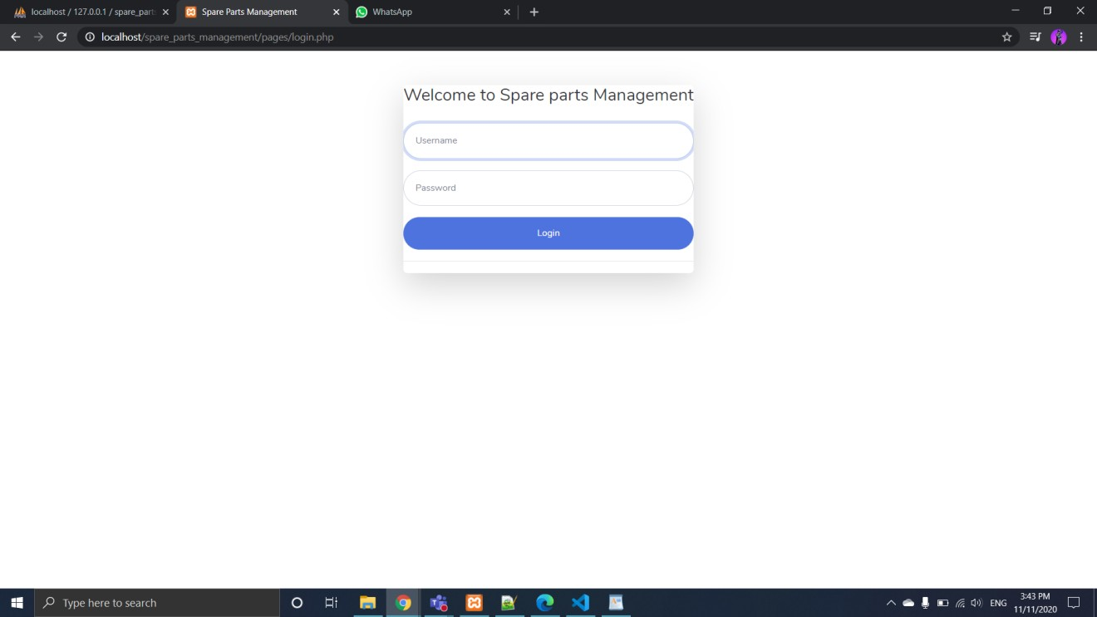
This is over login page. There are two types of login one for manager and one for cashier. The following screenshots is for manager login.

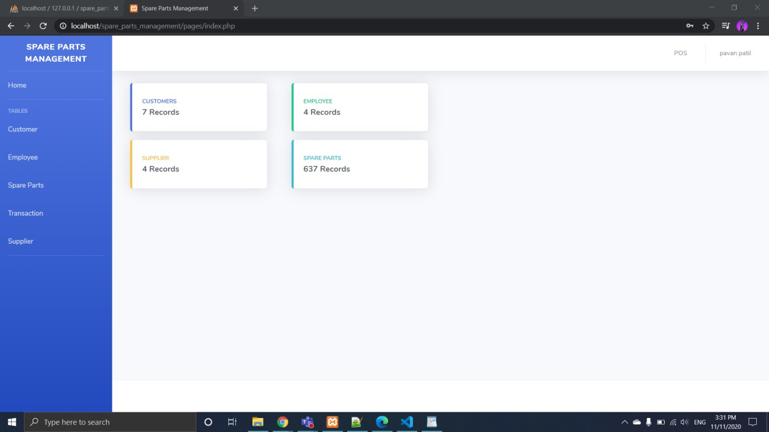
This is our home page. After entering correct username and password the manager will redirect to this page.
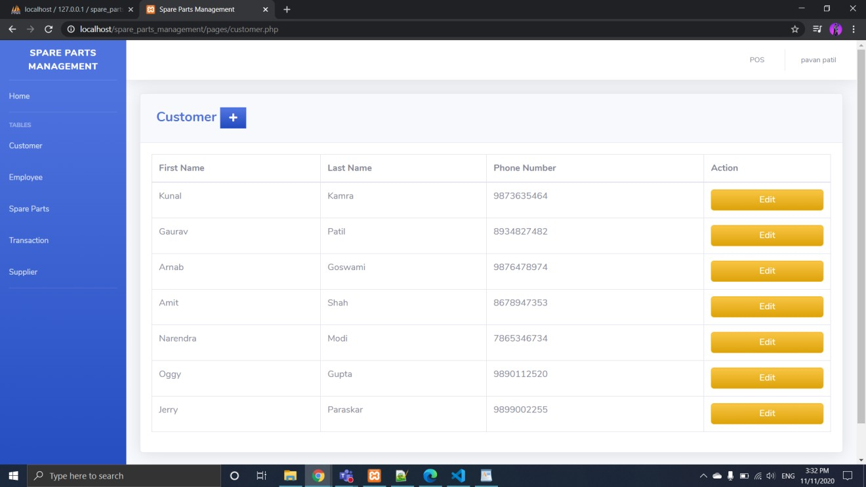
This is customer page. Here you will information about the entire customer who has buy product from you. When you click on edit, you can change the information about the customer.

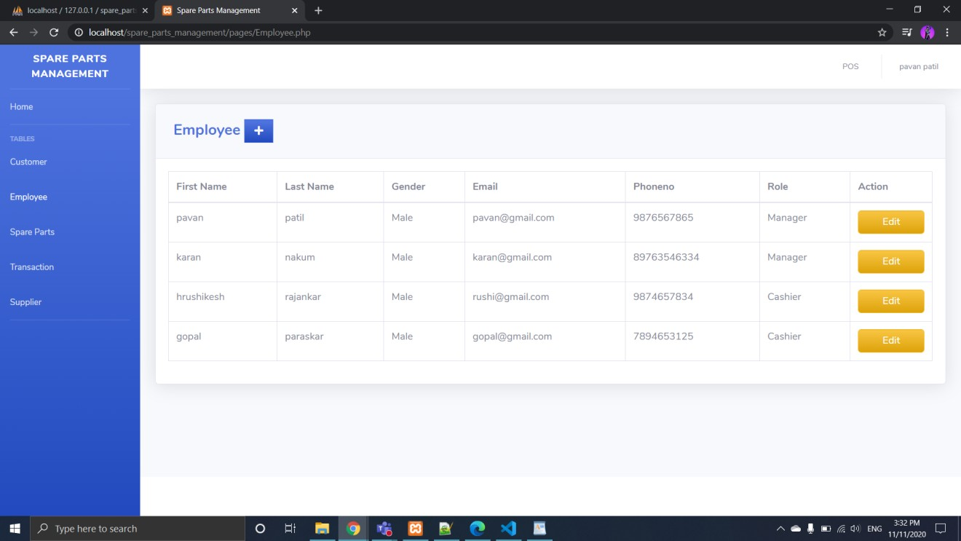
This is our employee page here you can add or remove employee name who are working with you or who was working with you.

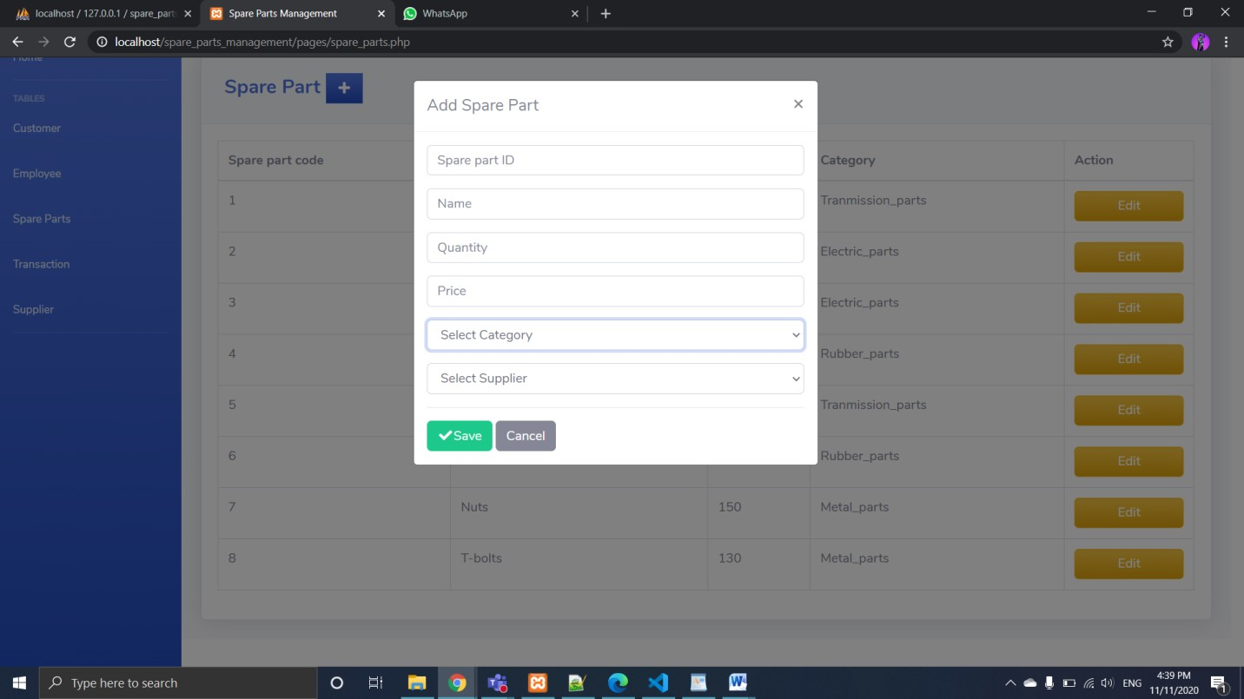
Here you add name of new spare part with their details.

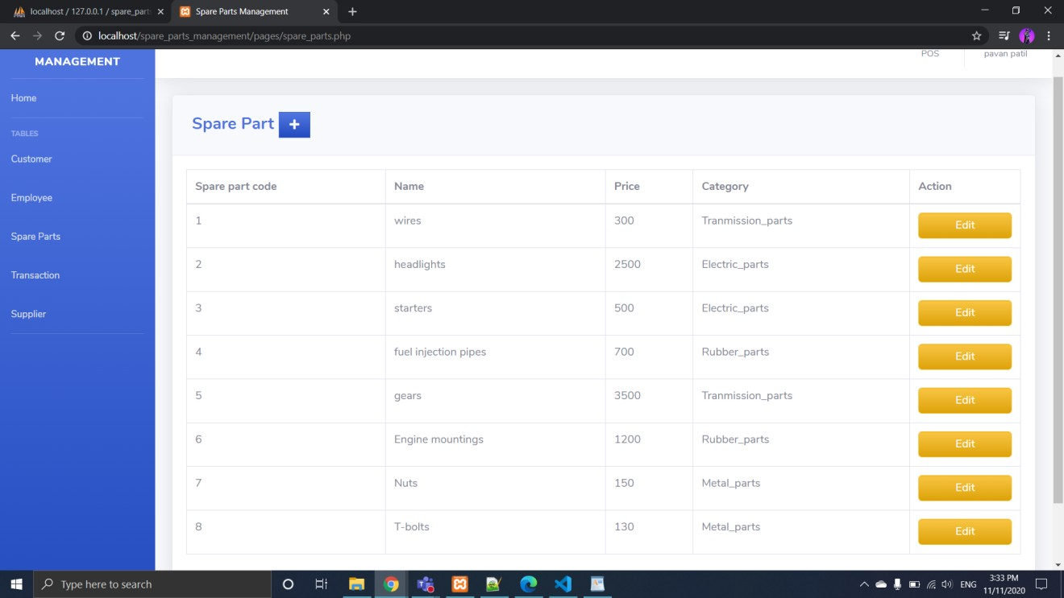
This is the page where you get all information about product you have in your shop.

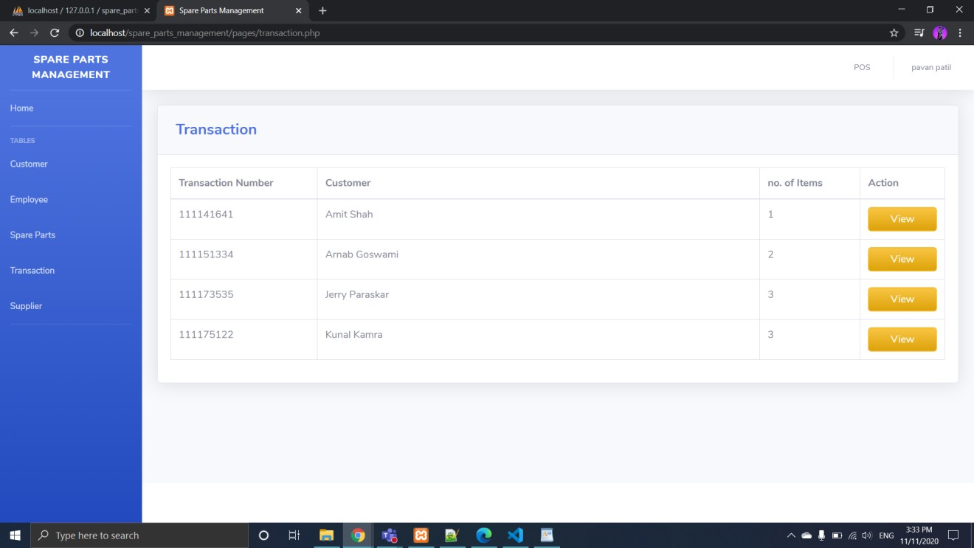
Here you will get transaction details of the entire customer. This will also show how much of their money are remaining to pay by clicking on view as below.

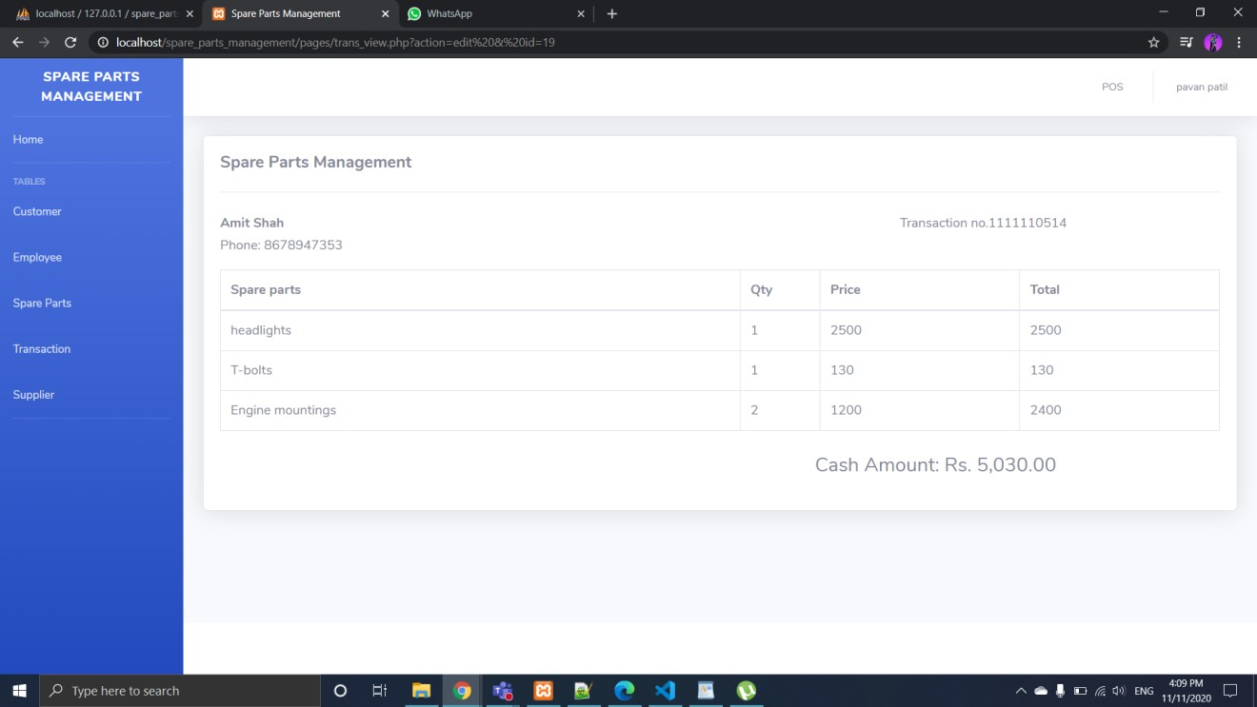

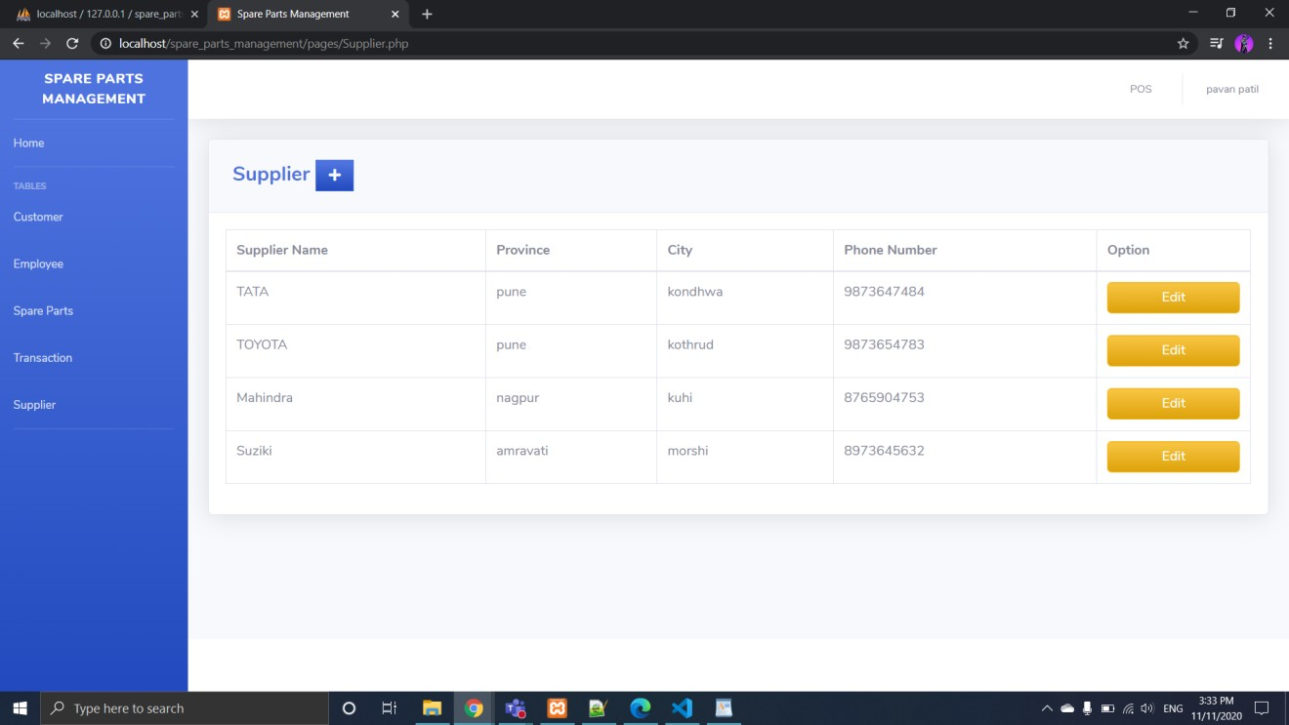
This page will show all the details of the supplier from whom we buys product to sell.

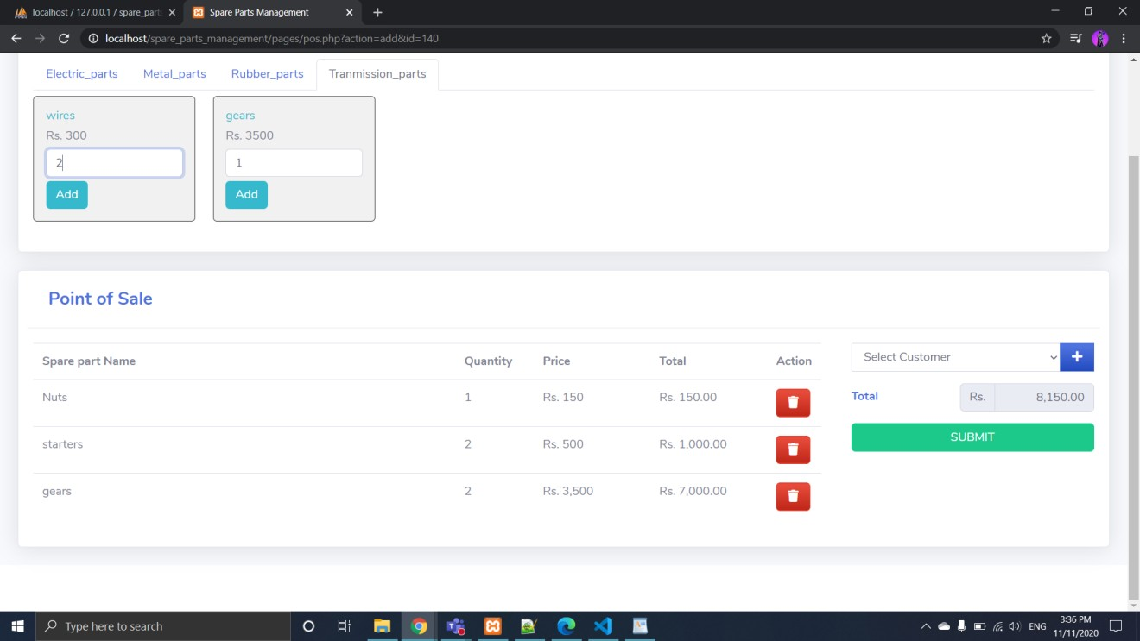
On right hand-side top you will find POS(point of sale) where we have created four categories. Here you add the product how much you want. If you have new user you can add on plus and add the user and create bill.

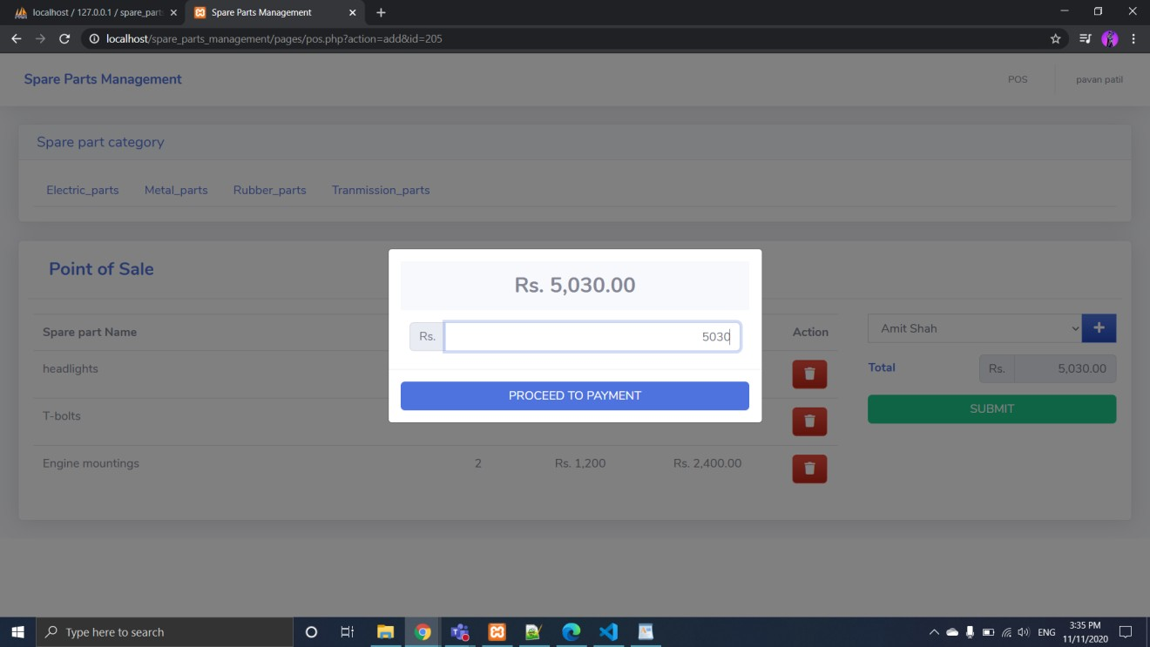
Here you enter amount to pay to the owner.

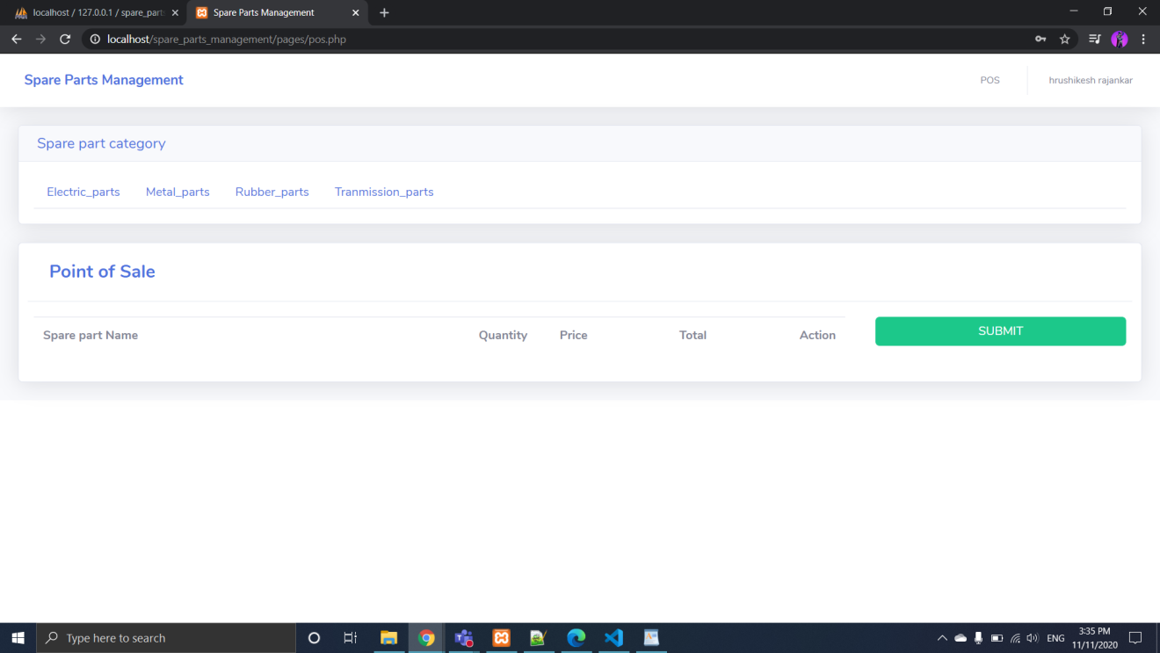
This page is for only cashier. Whenever, cashier login he will redirect to this page. Access of the cashier is limit to this page.


Here, cashier add the customer and make the bill.

Future Scope/Enhancement
As you see, IT industry is booming the industry from last few decades. It will keep on booming as you go on and on. As you see our project is limited to one user\owner. But, we can further expand this to multi-user to multi-customer and there is way we can do that. We all know that there and various online shopping application and website available for their basic need. But, there is no application or website available for the Automobile Spare Parts. These were we can enhance this project further. We can make an application like Amazon were you get every single piece of the spare part on your application and need to go anywhere to find it. By providing the best product at best prices everyone going to come and visit the site. We can show the picture of the product with the offers on the particular occasion.
We can also add the feature that how amount of work has been done by the employee at your shop and how leaves taken by him/her. We can also add online payment methods with the help of Google Pay, PhonePe etc.

Conclusion
At last we want to conclude that this application will decrease the overhead of the owner of the shop. It will be easily able to monitor the available stock present in the shop. It will also helpful for the owner that whose money is pending or how much he has to pay to the supplier. The main motivation behind this application is to reduce tension and easily monitor the current condition of the shop. Now there is no need of books and paper in the shop and manually keep track of each record.

Reference

http://docs.oracle.com/cd/B12037_01/server.101/b10739/create.htm

http://docs.oracle.com/javafx/index.html

http://stackoverflow.com/questions/15482623/javafx-1-3-listview

http://stackoverflow.com/questions/8392119/javafx-1-3-crud-using-listview

http://docs.oracle.com/cd/E17802_01/javafx/javafx/1.3/docs/api

https://www.tutorialspoint.com/php/index.htm

https://www.w3schools.com/php/DEFAULT.asp

“Database System Concepts” by Henry Korth.

“Mysql” by Paul Dubois.

